**User:**

I am a Mechanical Designer, proficient in SolidWorks drafting, and a recent graduate of the University of New South Wales. I would like you to act as both a knowledgeable designer who can provide me with design expertise and a professional engineering designer who can act as a technical advisor to me when I have complex questions.

For this project, I favoured a bio-inspired design approach, using principles found in nature to optimise energy harvesting.

Based on the above background, I will be designing an energy harvesting device.

The energy harvesting device shall require three key modules:

1. The energy accumulation module functions to derive energy from an external source outside the energy harvesting device.

2. The energy storage module functions to store the accumulated energy inside the energy

harvesting device.

3. The energy utilization module utilizes the harvested energy to power other small devices such as sensors, heating/cooling devices, actuators, and low-power devices.

Please give me as many and reasonable and complete designs as possible.

**GPT:**

Designing an energy harvesting device using a bio-inspired approach is an innovative and exciting project. Given your background and the specifications, here are some design concepts and considerations for each of the three key modules:

**1. Energy Accumulation Module**

* **Bio-Inspired Sources:** Consider biological mechanisms like photosynthesis or electroreception (used by sharks). A design mimicking photosynthesis could use solar panels for energy conversion. An electroreception-inspired design might harness electromagnetic fields.
* **Design Ideas:**
  + **Leaf-like Solar Panels:** Mimicking the structure of leaves, these panels could be efficient in capturing sunlight from various angles.
  + **Piezoelectric Materials:** Inspired by mechanical movements in nature (like a bird's wing flapping), these materials could generate energy from vibrations or wind.

**2. Energy Storage Module**

* **Bio-Inspired Storage:** Look at how animals store energy (like camels storing fat). A compact, high-efficiency battery inspired by biological energy storage mechanisms could be ideal.
* **Design Ideas:**
  + **Layered Battery Structure:** Similar to the layered fat storage in some animals, this could allow for more efficient energy storage.
  + **Bio-based Batteries:** Using bio-derived materials for batteries, which are environmentally friendly and efficient.

**3. Energy Utilization Module**

* **Bio-Inspired Efficiency:** Mimic natural systems' efficiency in energy usage, like how muscles use energy only when needed.
* **Design Ideas:**
  + **Smart Distribution System:** Like the nervous system distributing energy only when and where needed, this system could optimize energy use for attached devices.
  + **Adaptive Output:** Similar to how organisms adapt their energy consumption based on needs, the module could adjust its output based on the connected device's requirements.

**General Considerations**

* **Integration:** Ensure all modules are seamlessly integrated, perhaps using a design mimicking the interconnected systems found in organisms.
* **Material Selection:** Consider lightweight, strong materials inspired by biological materials like spider silk or bamboo.
* **Sustainability:** Focus on sustainable materials and processes, reflecting nature's cyclical use of resources.

**Prototype and Testing**

* **3D Modeling:** Use SolidWorks to create detailed models of your designs.
* **Simulation:** Test the designs under various conditions using simulation software to predict performance.
* **Iterative Design:** Be prepared to iterate on your designs based on testing outcomes and feedback.

Remember, these are starting points. As you delve deeper into the project, tailor these concepts to suit the specific requirements and constraints you encounter. Your expertise in SolidWorks and mechanical design will be invaluable in refining these ideas into practical, efficient designs.

**User:**

Based on the information I provided earlier, are there any other details I should provide regarding the design of the energy harvesting device?

**GPT:**

To further refine and enhance the design of your energy harvesting device, there are several additional details that you might consider providing. These details will help in tailoring the design to specific requirements and environments, ensuring the device's efficiency and effectiveness. Here are some aspects you might want to elaborate on:

**1. Energy Source Specifics**

* **Type of Energy Source:** Clarify whether the primary energy source is solar, wind, mechanical vibrations, thermal differences, etc.
* **Intensity and Availability:** Information on the expected intensity and availability of the energy source (e.g., average sunlight hours, wind speed, temperature gradients).

**2. Application Environment**

* **Operating Environment:** Details about the environment where the device will be used (e.g., outdoor/indoor, temperature range, weather conditions).
* **Space Constraints:** Any size or weight limitations for the device.

**3. Energy Demand**

* **Power Requirements:** The amount of power needed by the devices it will be powering (sensors, actuators, etc.).
* **Usage Patterns:** How often and for how long will the energy be utilized? (continuous vs. intermittent use).

**4. Material Preferences and Constraints**

* **Material Choices:** Preferences for specific materials (e.g., biodegradable, lightweight, high durability).
* **Cost Constraints:** Budget limitations for materials and manufacturing.

**5. Sustainability and Lifecycle**

* **Lifecycle Analysis:** Expected lifespan of the device and its components.
* **Recyclability and Disposal:** Considerations for end-of-life recycling or disposal.

**6. Regulatory and Safety Requirements**

* **Compliance Standards:** Any industry-specific or regional safety and performance standards that need to be met.
* **Certification Requirements:** If the device requires certification (e.g., for electrical safety, environmental impact).

**7. Integration and Interface**

* **Compatibility:** With other devices or systems (e.g., IoT compatibility, interface requirements).
* **User Interaction:** How users will interact with the device (e.g., any display or control features).

**8. Scalability and Adaptability**

* **Scalability:** If the design needs to be scalable for different power capacities or sizes.
* **Adaptability:** If the design should accommodate future upgrades or changes in technology.

Providing detailed information in these areas will significantly enhance the ability to create a more tailored, efficient, and practical design for your energy harvesting device.

**User:**

I like the minimalist and sleek design style of the energy harvesting device. It should look clean and modern without unnecessary details.

The energy harvesting device is planned to be deployed in a coastal urban environment in Australia. The design needs to take into account the city where it will be applied to ensure consistent energy output throughout the year. Installation must be straightforward. In terms of maintenance, the unit should be designed to minimise the need for frequent repairs and, where necessary, key components should be easily accessible.

The equipment must comply with Australian Standards for Electrical Equipment. The design should be compact to fit into the limited urban space where the installation is specified. Considering the budget of A$50,000, we should prioritise durable materials, balancing cost and longevity.

Based on previous outputs and above information, please give me as many and reasonable and complete designs as possible.

**GPT:**

Given your preference for a minimalist, sleek design, and the specific requirements for deploying the energy harvesting device in a coastal urban environment in Australia, here are several design concepts that align with these criteria:

**1. Solar Panel Array Design**

* **Structure:** Slim, modular panels with a sleek metallic frame. The minimalistic design focuses on clean lines and unobtrusive integration into urban settings.
* **Material:** Use of durable, corrosion-resistant materials suitable for coastal environments, like anodized aluminum or stainless steel.
* **Features:**
  + Adjustable angles for optimal sun exposure throughout the year.
  + Easy-to-install mounting system for urban structures like buildings or light poles.
  + Self-cleaning glass to reduce maintenance needs.

**2. Wind Turbine Design**

* **Structure:** Compact vertical-axis wind turbines with a modern aesthetic. Designed for low to moderate wind speeds common in urban areas.
* **Material:** Lightweight, durable materials such as carbon fiber or reinforced plastics.
* **Features:**
  + Minimal moving parts to reduce maintenance.
  + Noise-reduction technology to suit urban environments.
  + Easy installation on rooftops or alongside existing structures.

**3. Piezoelectric Energy Harvesting**

* **Structure:** Sleek, flat modules that can be installed in areas with high foot traffic or under roadways.
* **Material:** Robust materials capable of withstanding constant mechanical stress.
* **Features:**
  + Modular design for easy replacement or upgrade of components.
  + Non-slip, weather-resistant surface for safety and durability.

**4. Hybrid System**

* **Structure:** A combination of solar panels and wind turbines, integrated into a single unit with a cohesive, modern design.
* **Material:** Use of materials that are consistent across both systems for aesthetic unity.
* **Features:**
  + Smart energy management system to switch between solar and wind power based on availability.
  + Compact design to fit limited urban spaces.

**General Considerations**

* **Australian Standards Compliance:** Design to comply with Australian Standards for Electrical Equipment, with a focus on safety and reliability.
* **Budget Management:** Select materials and components that offer the best balance between cost, durability, and performance within the A$50,000 budget.
* **Maintenance and Accessibility:** Design components to be easily accessible for maintenance, with emphasis on longevity and minimal need for frequent repairs.

**Prototype and Testing**

* **3D Modeling and Simulation:** Use SolidWorks to create detailed models of the designs and simulate their performance in an urban coastal environment.
* **Prototype Development:** Build prototypes for field testing to validate design effectiveness and durability.

Each of these designs prioritizes a clean and modern aesthetic while considering the practical requirements of installation, maintenance, and compliance with Australian standards. They are tailored to function efficiently in an urban coastal context, making the most of the available natural resources with minimal environmental impact.

**User:**

Based on the design 1,2,3,4 you gave me above, please generate 4 visual concept diagrams.

**GPT:**

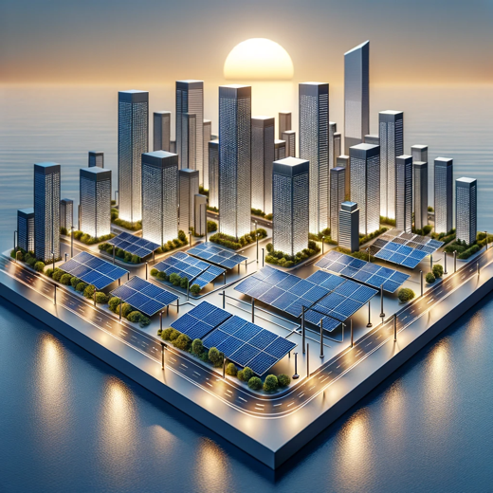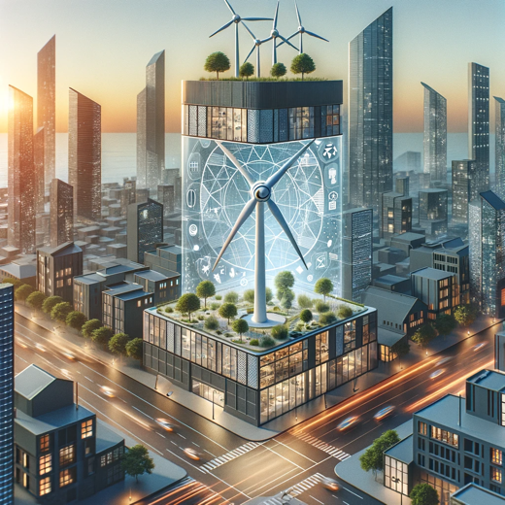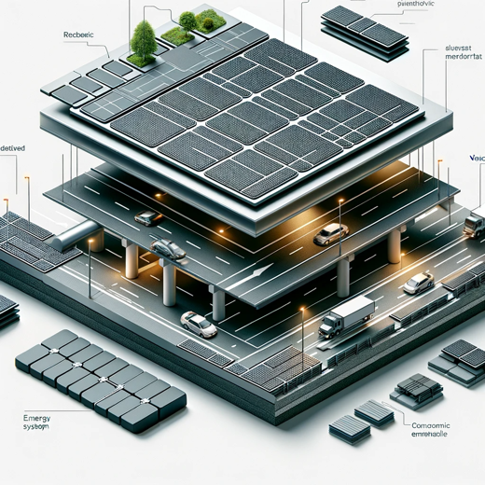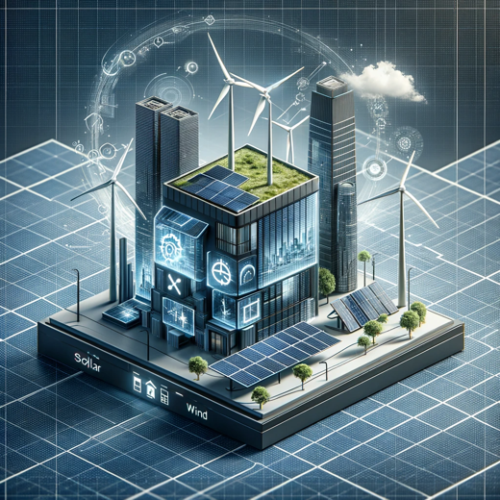

The visual concept diagrams for the energy harvesting systems have been generated. They visually represent each design concept:

1. The solar panel array designed for urban coastal environments.
2. The compact vertical-axis wind turbine suitable for urban environments.
3. The piezoelectric energy harvesting system for areas with high foot traffic or roadways.
4. The integrated hybrid energy system that combines solar panels and wind turbines.

Each design is envisioned to be sleek, minimalist, and suitable for the limited space available in urban settings, with a focus on blending into the urban landscape while efficiently harvesting energy.